Project I

Mastermind

Jeffrey Thomas

CSC-7, 42645

Dr. Mark Lehr

*Table of Contents*

Introduction………………………………………………………3

Summary…………………………………………………………3

Description…………………….…...…………………………….4

Flowcharts…………………….…...…………………………..5-7

Pseudocode……………………………...……………..……….8

Full Code……………...………………….…………………..9-13

Acknowledgements…………………………………………....14

*Introduction*

This is my clone of the game Mastermind. This version of the game takes in user input and does not have a working AI yet.

*Summary*

From start to finish, this project took approximately 8 hours to complete. This project utilizes interesting features such as colored pins. The project is just under 300 lines from the beginning of main to the end of the last function definition (including comments and spacing).

Line Count (w/o comments and spaces): ~200

Line Count (total): 295

Number of variables: 14

Number of constants: 1

Number of constructs: 31

Number of functions: 9 + main()

*Description*

The two primary problems I had in coding this game were as follows:

1. I needed to validate codes to ensure there were no repeating numbers in the code
2. I needed to properly validate guesses that did not give false positives when checking for ‘correct number, different location.’

With some clever manipulation of my for-loops, I was able to overcome these problems.

This game has 6 different digits that can be arranged into the 4-digit code. The code is nonrepeating (it does not have more than one of the same digit present)

Each digit has a corresponding color to aid the user in seeing what is happening on the screen and to make the game more visually appealing

*Flowcharts*

main

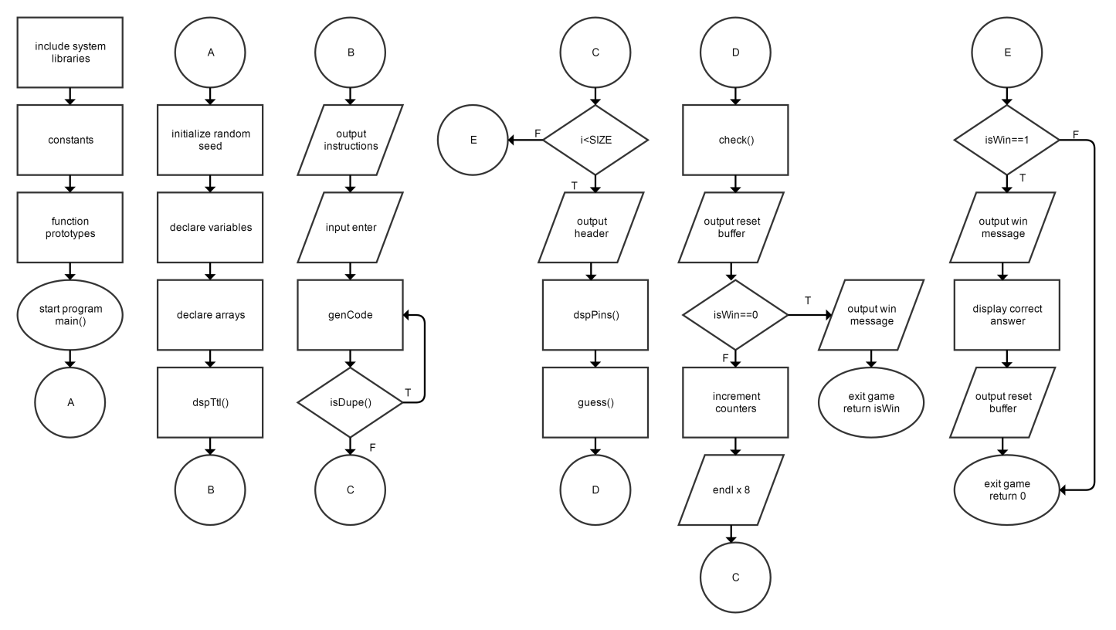

isDupe

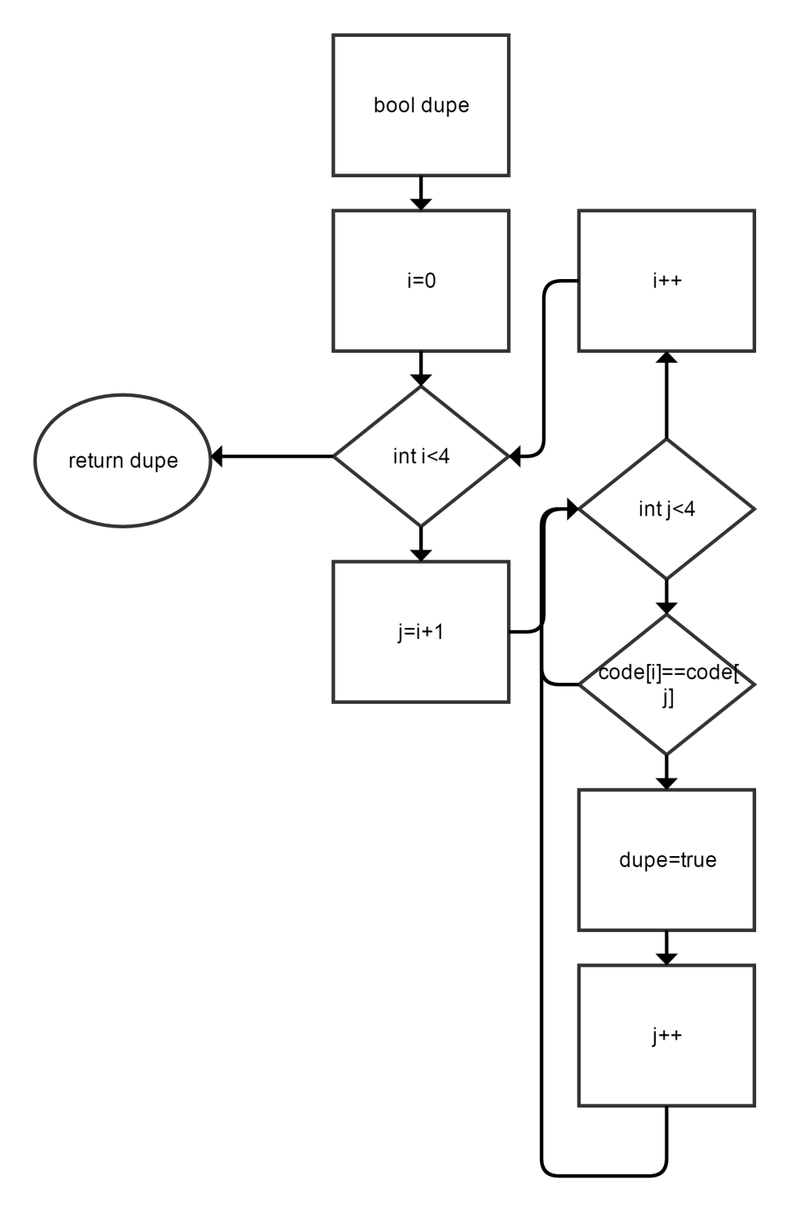

Check

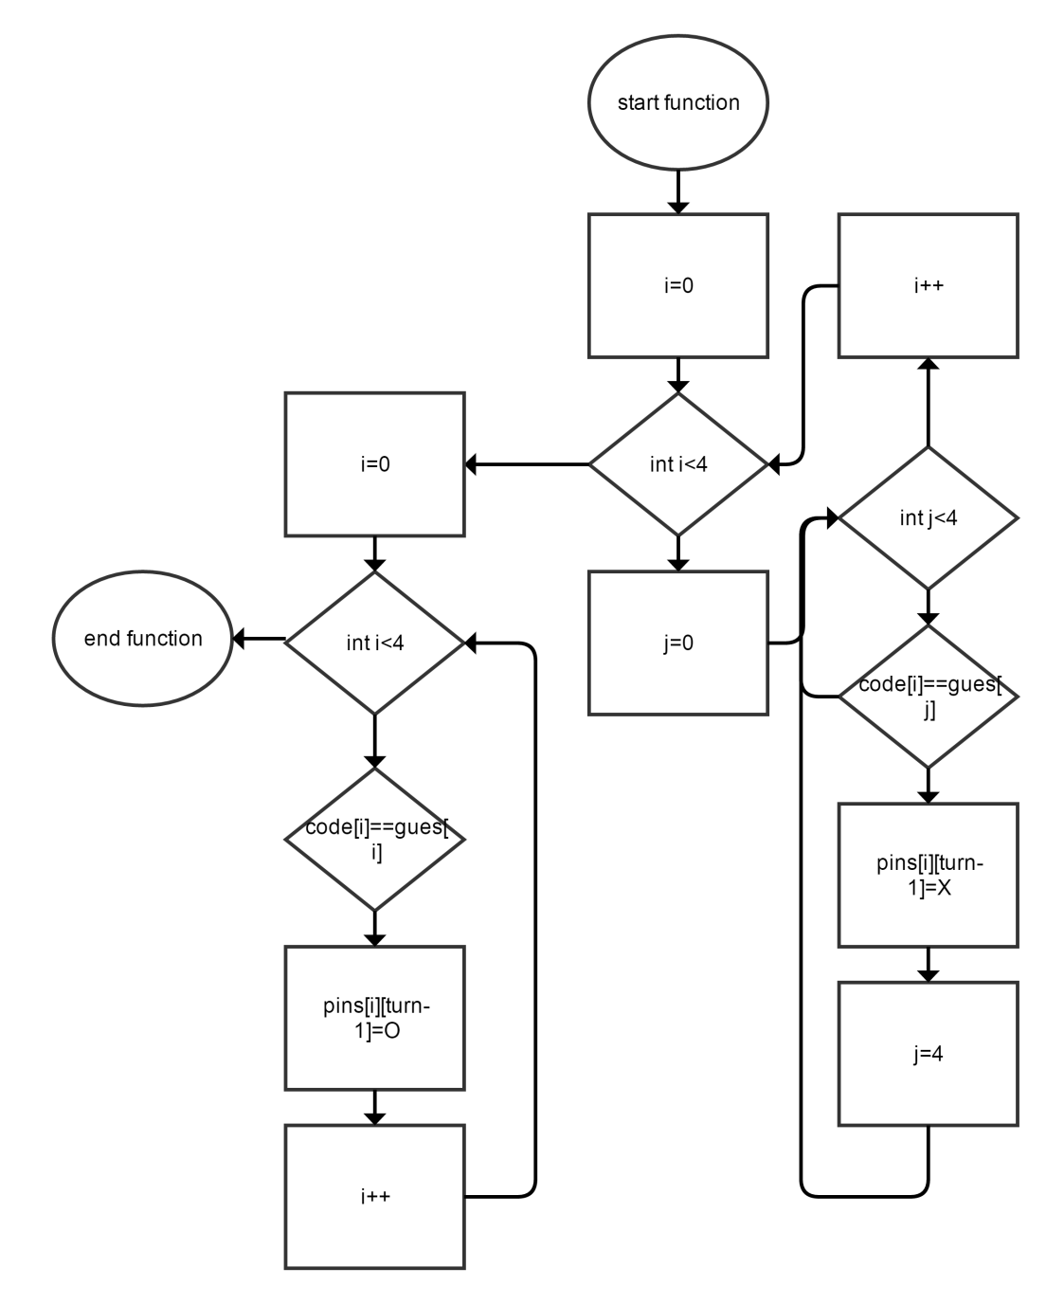

*Pseudocode*

*Include system libraries*

*Declare constants*

*Function prototypes*

*Main start*

*Declare Variables*

*Declare arrays*

*Display game title*

*Output instructions*

*Press enter to start*

*Create code until there are no duplicate numbers*

*Repeat 10 times*

*Display header*

*Display game board*

*Prompt for guess*

*Enter guess*

*Check which digits are correct*

*Sort correct characters*

*Reset color buffer*

*Check if player won*

*Display win message*

*Exit program*

*Increment turn*

*Output white space*

*Check if player lost*

*Display lose message*

*Display code*

*Reset color buffer*

*Exit program*

*Program*

/\*

\* File: main.cpp

\* Author: Jeffrey Thomas

\* Created on April 14th, 2017, 1:04 AM

\* Purpose: Project 1 CSC-7

\*/

//System Libraries

#include <iostream> //Input/Output objects

#include <cstdlib>

#include <ctime>

#include <fstream>

using namespace std; //Namespace used in system library

//User libraries

//Global constants

const int SIZE=10; //Size of 2D Array

//Function prototypes

void genCode(char[]);

void dspCode(char[]);

void dspPins(char[][SIZE],char[][SIZE]);

void dspTtl(char[]);

char guess(int,char[],char[][SIZE]);

char check(char[][SIZE],char[],char[],int);

void sortPin(char[][SIZE],int);

bool isDupe(char[]);

bool isWin(char[][SIZE],int);

//Execution begins here

int main(int argc, char\*\* argv)

{

//Initialize random seed

srand(time(0));

//Declaration of variables

int turn=1; //Counter for which number guess the player is on

char temp; //Placeholder for start menu input

//Declare Reset Color Buffer Code

string reset="\033[0m";

//Declare file name

char file[]="title.txt";

//Declare arrays

char hist[4][SIZE]={}; //Array holding previous guesses

char code[4]={}; //Computer generated answer code

char gues[4]={}; //User generated guess

char pins[4][SIZE]={'-','-','-','-',//Pins to determine correct or incorrect

'-','-','-','-',

'-','-','-','-',

'-','-','-','-',

'-','-','-','-',

'-','-','-','-',

'-','-','-','-',

'-','-','-','-',

'-','-','-','-',

'-','-','-','-'};

//Output Game Title

dspTtl(file);

//Prompt user with instructions and input

cout<<"The computer will generate a random nonrepeating 4-digit code"<<

endl<<"containing numbers 1-6"<<endl<<endl;

cout<<"You have 10 attempts to crack the code."<<endl<<endl;

cout<<"Press ENTER to start"<<endl;

cin.get(temp);

//Generate Code

do{

genCode(code);

//Generate until code with no duplicate numbers is created

}while(isDupe(code));

for(int i=0;i<SIZE;i++){

//Output HUD

cout<<" ? ? ? ? "<<endl<<endl;

//Output Game Board

dspPins(hist,pins);

//Prompt user for guess

cout<<"Enter your guess:"<<endl;

guess(turn,gues,hist);

//Check answer

check(pins,code,gues,turn);

//Sort pins so as to not give away answer

sortPin(pins,turn);

//Reset color buffer

cout<<reset;

//Check if game is won

if(isWin(pins,turn)==0){

cout<<"A winner is you!"<<endl;

cout<<"You cracked the code in "<<turn<<" guesses!"<<endl;

return isWin(pins,turn);

}

//Increment turn

turn++;

//Make space

cout<<endl<<endl<<endl<<endl

<<endl<<endl<<endl<<endl;

}

//Display loser message

if(isWin(pins,turn)==1){

cout<<"Loser!"<<endl;

cout<<"The code was: "<<endl;

dspCode(code);

cout<<reset;

}

//Exit program

return 0;

}

*Acknowledgements*

Augies Coffee Roasters

Dr. Mark E. Lehr

All of my programmer friends who aren’t as good as me